Arts & Humanities Individual Course Submission Template
Please name the file with course prefix and number (i.e. ART 220) and send as an email attachment to: ahcourses@share.calstate.edu
Jump to Review and Approval Cycle
Yellow highlight indicate fields that must be complete, or documents / information that must be attached.

Course Information
Complete for all courses
Course Prefix | Course Number | Course Title | Textbook
[Course Prefix] | [Course Number] | [Course Title] | [Default Textbook]

Type of Course Conversion
Select Type of Course Conversion: [Type of Course Conversion]
Course Type | Definition | Information Needed
New | A new course is proposed. The rationale, place in the curriculum, and resource implications are contained in the accompanying proposal summary. This form contains the proposed course number, title, default textbook, catalog description, and PeopleSoft entries. | - Textbook  - Syllabus  - Catalog Description  - PS Catalog
Unchanged | The course has been offered in the last five years and will be converted from a 5-quarter-unit course into 3-semester unit course with no other changes in the catalog, PeopleSoft system, or course articulation. | - Textbook  - Syllabus
Changed | The course has been offered in the last five years and will be converted into a 3-semester unit course (or closest semester equivalent) with the changes indicated in this document. Unless otherwise indicated, there will be no other changes in the catalog, PeopleSoft system, or course articulation. | - Textbook  - Syllabus  Updates To (if applicable)  - Catalog Description  - PS Catalog
Elective Inactivation | The course is an elective course, will be inactivated, and will no longer be printed in the catalog. The course can be reactivated if it will be consistently taught. Since the course is not required in any program, there will be no need to make student accommodations for this category. | - No additional information required
Required Inactivation | The course was a required course that will not be offered in the semester system. If an outside department requires the course, that department/program chair will need to approve the accommodation.  Describe Accommodation: List whether students will be accommodated by a waiver of that requirement, a substitution, or some other action.  [Enter Accomodation Here] | - Accommodation
Catalog Description and Course Syllabus
IMPORTANT INSTRUCTIONS
- To turn on “Track Changes” locate Review > Track Changes in the top menu and then make your proposed changes to the catalog description. Need Help ? See Tip Sheet
- To attach the Course Syllabus, locate Insert > Object > Attach as File and browse to locate and upload your syllabus. Need Help ? See Tip Sheet
- To submit the course, follow these steps:
- Save the file using the Course Name and Number as the filename. Example: ART 220
- When done, attach the file to an email and send the email to ahcourses@share.calstate.edu
Catalog Description
If changes to the catalog description are proposed, enter the existing description and make the proposed changes with tracking on to show the changes. Existing course descriptions are found here.
Catalog Description
Attach Course Syllabus
Attach the master syllabus or sample syllabus to this template by placing your cursor after this paragraph, then locating the Insert Tab in the top ribbon and find Insert > Object > Attach as File.
>
Changes to PeopleSoft Catalog (only required for new courses)
You can skip this section for most course modifications that require no changes to prerequisites or modes of instruction. If changes are necessary, please enter the changes below. Use only the primary component unless the course involves two modes of instruction (combined lecture/lab course)
Course Components | Component Units | CS# | Grading Basis* | Pre-requisites | Corequisites | Action or Changes Required
Primary Course Component |  | [CS# (Primary)] | [Grading Basis (Primary)]
Secondary Course Component (optional) |  | [CS# (Secondary)] | [Grading Basis (Secondary)]
* RP Grading Basis requires approval from the Academic Programs office.

Review and Approval Cycle
Please select one value from the following drop-down field that represents the review/approval cycle. Each value triggers a workflow notification to start review by the department, curriculum committee, dean, and final approval.
Select Review and Approval Cycle: Submitted
Reviewers
Please enter the name of who is conducting the review for each step of the review cycle.
Review Cycle | Name | Date Complete | Comments / Revision Requests
Department | [Dept Reviewer] | [Dept Review Date]
Curriculum Committee | [CC Chair] | [CC Review Date]
Q2S Exceptions Committee | [Q2S CCC Chair] | [Q2S CCC Review Date] | This Review Level only applies to exceptions and interschool programs.
Dean (Final Approval} | [Dean Approver] | [Dean Approval Date]

Tip Sheet
How to Turn on Tracking to Update Your Course Description and How To Upload Your Course Syllabus
Turn on Tracking
Turn on tracking if you are making changes to your course description. Enter your existing course description in the appropriate section, turn on tracking, make your proposed changes to your course description, then turn tracking back off.
Steps | Screen Shot
- Locate and click on the “Review” tab in the top ribbon  - Click on the icon for “Track Changes”  When the icon is yellowed, tracking is on. Click again to turn tracking off. | 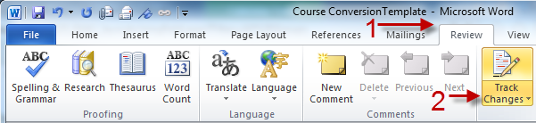
Upload Your Course Syllabus
Hint: Make sure your Cursor is clicked in the correct place in this document, where we ask you to attach the syllabus before you complete these steps!
- Locate and click on the “Insert Tab”
- Locate and click on the down arrow next to the word “Object” . From the drop-down, select “Object”.
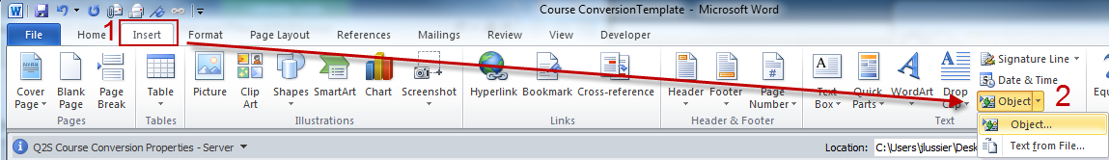
Selecting Object launches a dialog window (left screen)
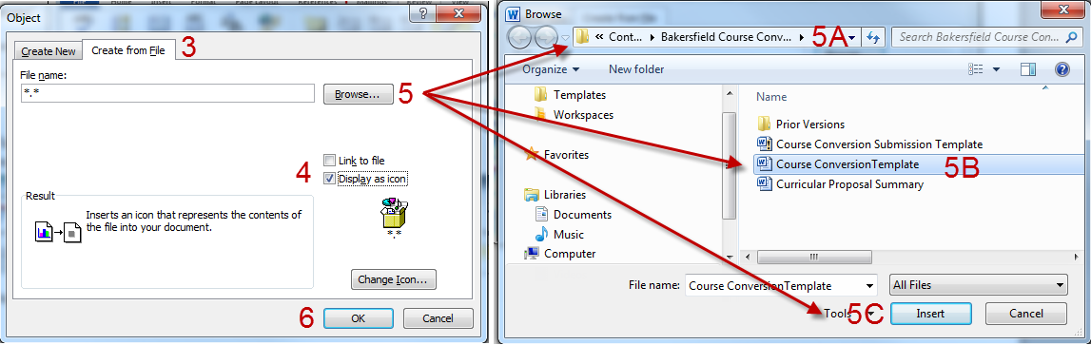
- Click the tab “Create From File”
- Select the checkbox “Display as Icon”
- Click “Browse” to launch the Browse dialogue box (right screen displayed above)
  - Use the top bar to navigate to where the course syllabus is located on your computer
  - Click on the filename
  - Click the “Insert” button
- You will be returned to the Insert Object screen, Click “OK” This will insert an icon of your course syllabus.

